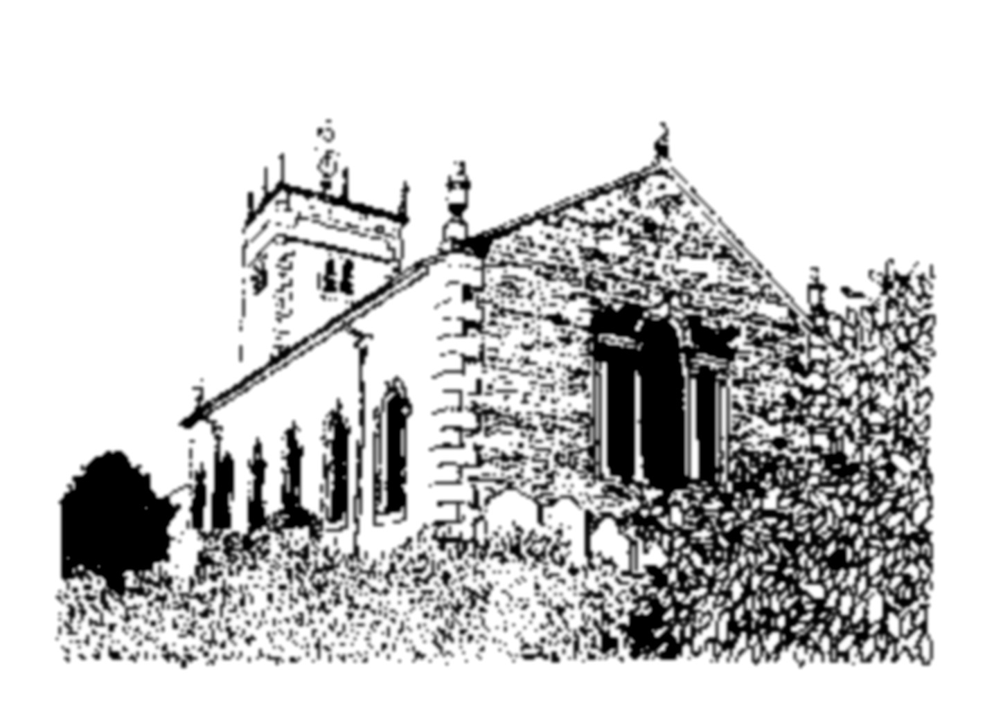
SOLAR PANELS FOR INGS CHURCH

EXPRESS YOUR SUPPORT TO SUSTAIN THIS HISTORIC, PUBLIC, COMMUNITY
AND FAITH SPACE FOR INGS and ITS WIDER COMMUNITY

I/we support the proposal for installation of solar panels at St Anne’s Church, Ings, LA8 9PY*:
- it reduces the electricity costs making use of the Church affordable
- using the church protects the fabric of the building, saving it from neglect thus protecting its architectural heritage
- the installation of solar panels creates minimal visual impact and is completely reversible, leaving no trace
- it supports St Anne’s Church as an important, much-used and much-loved community asset, the only large public space in Ings
- generating low carbon energy to drive the existing heat-pump is an outstanding example of sustainable development in action

Individual supporters of St Anne’s Church
Name |  | Postcode |  |  | Date
Resident of Ings | Church member |  | User group member | Non resident supporter
Please tick as appropriate.

User groups of St Anne’s Church
Name of group |  | Date
Role (eg chairperson, organiser)
Number of people in group

Organisations beyond Ings
wishing to give support for the benefit of St Anne’s Church, to encourage more historic, community and faith buildings to install solar panels
Name of group |  | Date
Role (eg chairperson, organiser)
Number of people in group

We would welcome any comments:

Please note that personal details will not be used when information from this survey is used, for example, in any future planning re-application, to write to press, MP, etc. Please return this form to the collection box in St Anne’s Church or to John Hiley at Woodside Cottage, Ings, LA89PY or to ingsvillage@gmail.com

*As submitted to the Lake District National Park by John Hiley, Churchwarden (solar panels on the south-facing roof, out of sight of the A591
– this application refused at appeal in 2024), and in future follow-up applications to relevant authorities.

